**SQL Project on Music Data**

**Q1. Who is the senior most employee based on job title?**

**Answer: Here the employee table**

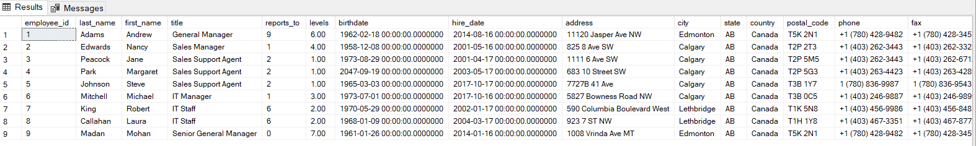

**select * from employee  
order by levels desc**

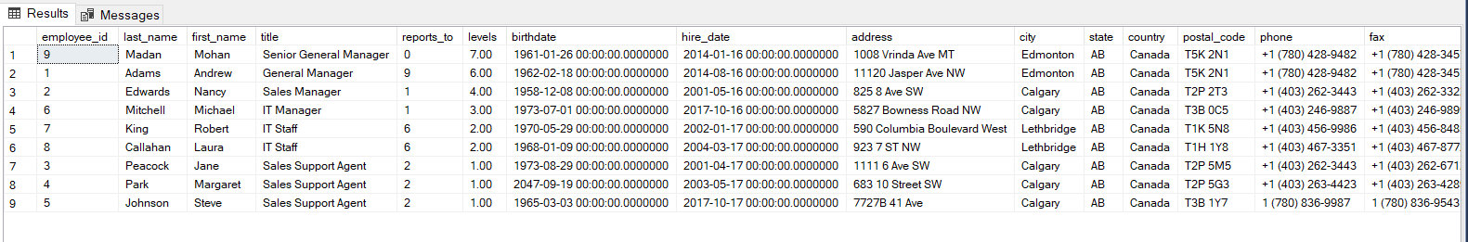

**select top 1 *   
from employee  
order by levels desc;**



**Q2. Which Countries have the most invoices?**

**Select * from invoice;**

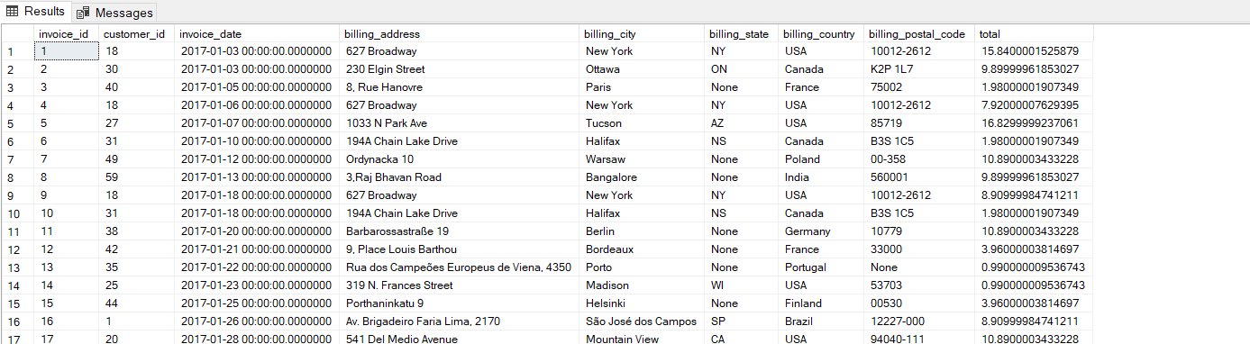

**Select count(*) as c,billing_country**

**from invoice**

**group by billing_country**

**order by c desc;**

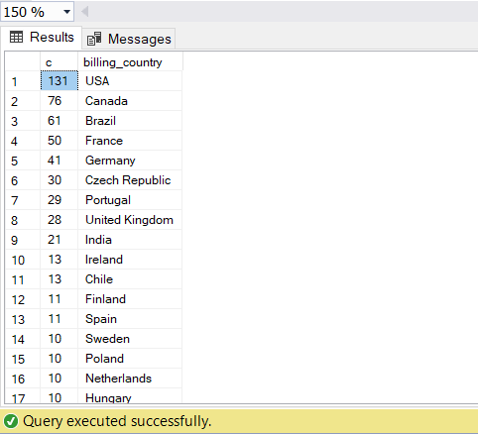

**Q3. What are top 3 values of total invoice?**

**Select total from invoice**

**order by total desc**

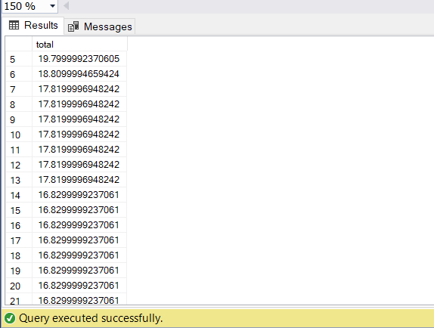

**Select top 3 total from invoice**

**order by total desc**

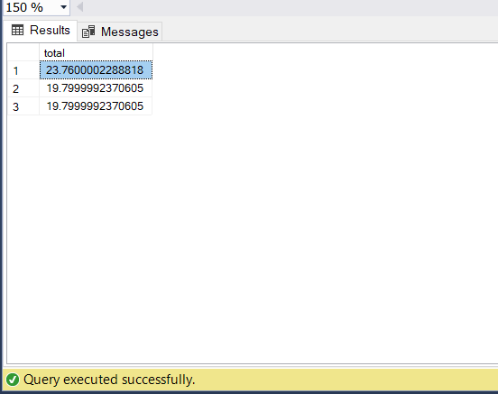

**Q4. Which city had the best customers? We would like to throw a promotional Music festival in the city we made the most money. Write a query that returns one city that has the highest sum of invoice totals. Return both the city name & sum of all invoice totals.**

**Select sum(total)as Invoice_Total, billing_city  
from invoice   
group by billing_city  
Order by Invoice_Total DESC**

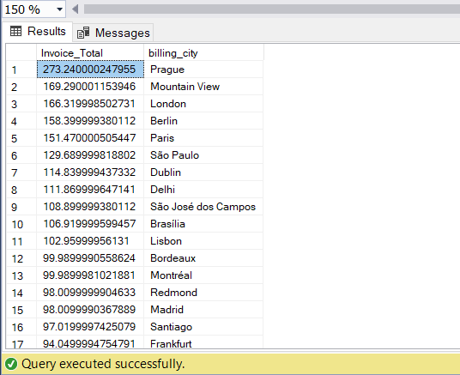

**Select top 1 sum(total)as Invoice_Total, billing_cityfrom invoice   
group by billing_city  
Order by Invoice_Total DESC**

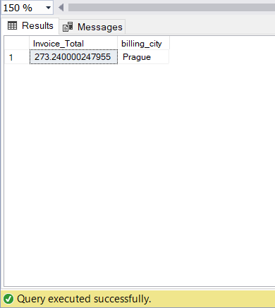

**Q5. Who is the best customer? the customer who has spent the most money will be declared the best customer. Write a query that returns the person who has spent the most money.**

**Select invoice.customer_id,customer.first_name as FS, customer.last_name as LS,sum(invoice.total) as Total   
from invoice  
FULL Join customer on invoice.customer_id = customer.customer_id  
group by invoice.customer_id, customer.first_name, customer.last_name  
Order by Total desc**

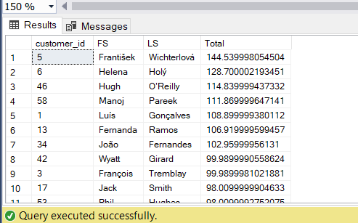

**Select top 1 invoice.customer_id,customer.first_name as FS, customer.last_name as LS,sum(invoice.total) as Total   
from invoice  
FULL Join customer on invoice.customer_id = customer.customer_id  
group by invoice.customer_id, customer.first_name, customer.last_name  
Order by Total desc**

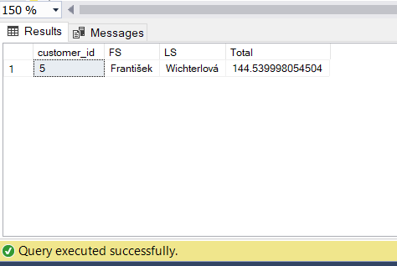

**Q6:Write query to return the email,first name, last name, & genre of all rock music listeners. Return your List ordered alphabetically by email starting with A.**

**SELECT DISTINCT**

**customer.email AS email,**

**customer.last_name,**

**genre.name AS genre_name**

**FROM customer**

**JOIN invoice ON customer.customer_id = invoice.customer_id**

**JOIN invoice_line ON invoice.invoice_id = invoice_line.invoice_id**

**JOIN track ON invoice_line.track_id = track.track_id**

**JOIN genre ON track.genre_id = genre.genre_id**

**WHERE genre.name LIKE 'Rock'**

**ORDER BY email;**

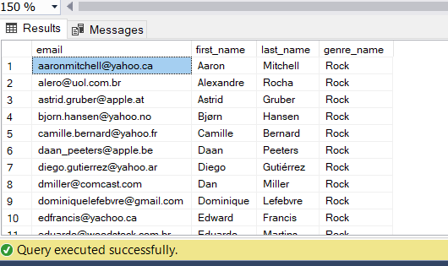

**Q7. Lets invite the artists who have written the most rock music in our dataset. write a query that return the artist name and total track count of the top 10 rock bands.**

**Select top 10**

**artist.artist_id,**

**artist.name as N,**

**count(artist.artist_id) as number_of_songs**

**From track**

**Join album on album.album_id = track.album_id**

**Join artist on artist.artist_id = album.artist_id**

**join genre on genre.genre_id = track.genre_id**

**where genre.name like 'Rock'**

**Group by artist.artist_id, artist.name**

**order by number_of_songs desc**

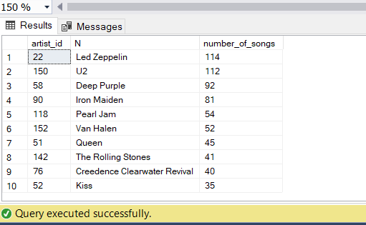

**Q8. Return all the track names that have a song length longer than the average song length. Return the name and millisecond for each track. Order by the song length with the longest song listed first.**

**Select name,milliseconds**

**from track**

**where milliseconds >(**

**Select AVG(milliseconds) as avg_length**

**from track)**

**order by milliseconds desc**

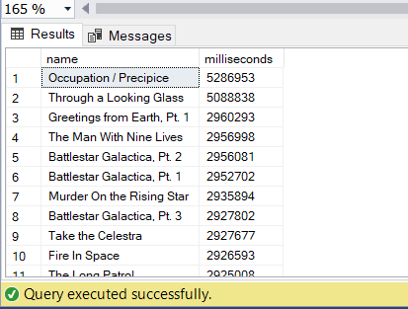

**Q9. Find how much amount spent by each customer on artists?Write a query to return customer name artist name and total spent.**

**WITH best_selling_artist AS (**

**SELECT TOP 1**

**artist.artist_id AS artist_id,**

**artist.name AS artist_name,**

**SUM(invoice_line.unit_price * invoice_line.quantity) AS total_sales**

**FROM invoice_line**

**JOIN track ON track.track_id = invoice_line.track_id**

**JOIN album ON album.album_id = track.album_id**

**JOIN artist ON artist.artist_id = album.artist_id**

**GROUP BY artist.artist_id, artist.name**

**ORDER BY total_sales DESC**

**)**

**SELECT**

**c.customer_id,**

**c.first_name,**

**c.last_name,**

**bsa.artist_name,**

**SUM(il.unit_price * il.quantity) AS amount_spent**

**FROM invoice i**

**JOIN customer c ON c.customer_id = i.customer_id**

**JOIN invoice_line il ON il.invoice_id = i.invoice_id**

**JOIN track t ON t.track_id = il.track_id**

**JOIN album alb ON alb.album_id = t.album_id**

**JOIN best_selling_artist bsa ON bsa.artist_id = alb.artist_id**

**GROUP BY c.customer_id, c.first_name, c.last_name, bsa.artist_name**

**ORDER BY amount_spent DESC;**

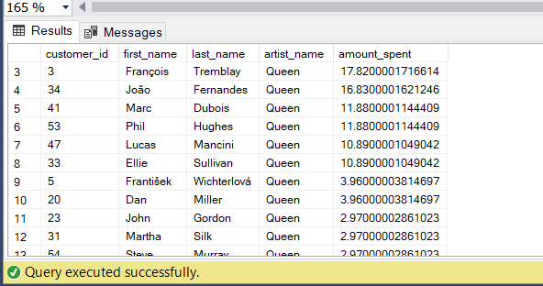

Q10. We want to find out the most popular music genre for each country. we determine the most popular genre as the genre with the highest amount of purchase. write a query that returns each country along with the top genre. For countries where the maximum number of purchases us shared return all genres.

WITH popular_genre AS (

SELECT

COUNT(il.quantity) AS purchases,

c.customer_id,

g.name AS genre_name,

g.genre_id,

ROW_NUMBER() OVER (

PARTITION BY c.country

ORDER BY COUNT(il.quantity) DESC

) AS RowNo

FROM invoice_line il

JOIN invoice i ON i.invoice_id = il.invoice_id

JOIN customer c ON c.customer_id = i.customer_id

JOIN track t ON t.track_id = il.track_id

JOIN genre g ON g.genre_id = t.genre_id

GROUP BY c.customer_id, g.name, g.genre_id, c.country

)

SELECT *

FROM popular_genre

WHERE RowNo <= 1;

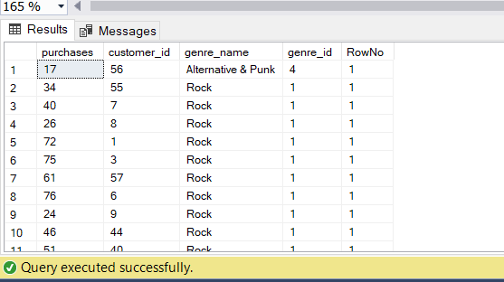

Q11. Write a query that determines the customer that has spent the most on music for each country. Write a query that returns the country along with the top customer and how much they spent. For countries where the top amount spent is shared, provide all customer who spent this amount.

WITH customer_with_country AS (

SELECT

c.customer_id,

c.first_name,

c.last_name,

i.billing_country,

SUM(i.total) AS total_spending

FROM invoice i

JOIN customer c ON c.customer_id = i.customer_id

GROUP BY c.customer_id, c.first_name, c.last_name, i.billing_country

),

country_max_spending AS (

SELECT

billing_country,

MAX(total_spending) AS max_spending

FROM customer_with_country

GROUP BY billing_country

)

SELECT

cc.billing_country,

cc.total_spending,

cc.first_name,

cc.last_name

FROM customer_with_country cc

JOIN country_max_spending ms

ON cc.billing_country = ms.billing_country

WHERE cc.total_spending = ms.max_spending

ORDER BY cc.billing_country;

